Vila Central Hospital Medical Elective
31/12/2024 – 24/01/2025
“Gud moning, Hemi oraet?”- a familiar friendly phrase that I exchanged countless times on my walk to the hospital each morning during my life-changing medical elective in Port Vila Central Hospital.
Reflecting on my elective, I am struck by the profound impact this experience had on both my personal and professional development. My Grandpa worked in Vanuatu in the early 2000’s, so it was very special to have this shared experience with him.
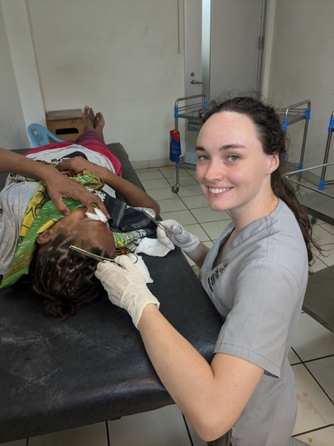
During my elective, I undertook two two-week placements—one in the emergency department (ED) and the other on the medical ward. Each offered unique insights and challenges that enhanced my clinical skills and broadened my awareness of global health.
The emergency department placement was an incredible opportunity to practise my practical and communication skills. From day one, the hands-on nature of the work became apparent. On New Year’s Day, the department saw a surge of patients requiring sutures, and my fellow medical students and I had the chance to take the lead in what became an impromptu “suturing clinic” supervised by the dedicated nursing staff. This experience was invaluable in building my confidence in performing procedures under pressure. Additionally, I gained significant practice in cannulation, which at times required lateral thinking to overcome challenges (such as using a glove as a tourniquet due to the limited supply). Beyond the technical aspects, working in the ED honed my communication skills as I navigated language barriers and adapted to the cultural nuances of patient interactions. It inspired me to start learning Bislama, which, while my initial attempts were shaky, were greatly appreciated by the patients.
Suturing on New Years Day!
In contrast, my placement on the medical ward focused more on clinical decision-making and developing a holistic approach to patient care. The limited resources of the hospital forced me to think critically about the necessity of investigations and treatments, sharpening my diagnostic skills and teaching me to rely on clinical judgment over diagnostic tests. One impactful situation was hearing of a patient requiring a CT (a standard tool in Australia) to investigate ongoing headaches. As a CT is not currently available in Vanuatu, they would need to acquire a passport and book a return flight to Fiji. This made me realise the challenges that limited-resource settings face, placing stress on the hospital, health staff and patients.
I had the privilege of learning from inspiring mentors who were generous with their time and expertise, offering insights into managing complex cases in a developing country. I am deeply grateful for their guidance, which not only enriched my clinical knowledge but also reinforced the importance of mentorship in medicine.
Another highlight of my elective was meeting the AUSMAT (Australian Medical Assistance Team), who were in Port Vila assisting the hospital’s recovery effort after the recent earthquake. They brought a unique dynamic to the hospital, as they provided life-saving surgeries and worked alongside the local team to restore services. Observing their operations was both inspiring and educational, offering a glimpse into the critical role of international aid in disaster response. It also reinforced my desire to contribute to similar efforts in the future, particularly in the Pacific region.
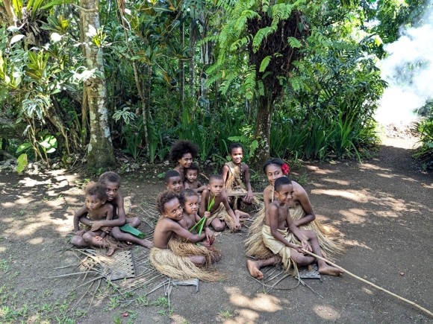
There were many unique and memorable experiences I still smile about, such as eating mangoes on our first day in the ED or the collaborative atmosphere in the hospital- working alongside nurses to complete tasks and sharing knowledge with my peers. The opportunity to conduct clinical exams on patients with clear, real signs of pathology (something seen to a lesser extent in Australia due to the early diagnosis and treatment of most conditions) was invaluable learning. These experiences highlighted the importance of being adaptable, resourceful, and in tune with the needs of the community.
Outside of the hospital, I embraced the opportunity to explore the island of Efate and immerse myself in Vanuatu’s vibrant culture. Snorkelling at various breathtaking locations, sampling local Tanna coffee, and experiencing island life were all unforgettable. A particular highlight was visiting the Ekasup Cultural Village, where I learned about the history and traditions of Vanuatu. This deepened my understanding of the community and highlighted the importance of cultural competence in medicine. I also loved tasting the local delicacies of Kava and island kakae!
Children at the Ekasup cultural village tour
Meeting nurses who remembered my Grandpa from 20 years ago was a full-circle moment which reinforced my desire to return to Vanuatu in the future as a practicing doctor, to continuing his legacy and give back the community that has so greatly impacted me.
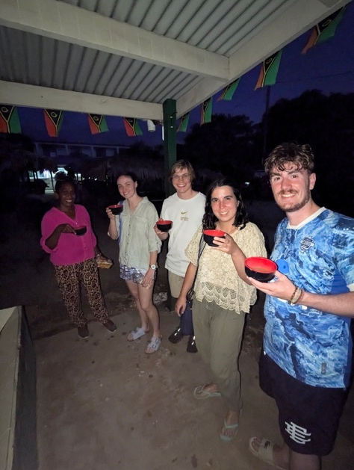
As I reflect on my time in Vanuatu, I am struck by the kindness and resilience of its people. Despite the challenges they face, the warmth and friendliness of the staff, patients, and wider community left a lasting impression on me. The experience has also highlighted the critical need for ongoing medical education and support in the region. While health literacy is improving, there is still much to be done to bridge gaps in healthcare delivery and access. I am eager to return in the future not only to provide medical care but also to contribute to education and capacity-building efforts that will empower local healthcare providers.
In conclusion, my medical elective at Vila Central Hospital was a transformative experience that enriched my skills, broadened my perspective, and strengthened my commitment to global health. The lessons I learned about clinical decision-making, cultural competence, and working in resource-limited settings will stay with me throughout my career. I am profoundly grateful for the mentorship I received, the connections I made, and the opportunity to follow in my grandfather’s footsteps. While it was difficult to leave, I am excited about the prospect of returning to Vanuatu in the future, both to give back to the community and to continue learning from its remarkable people.
I am extremely grateful for the Andrew Dent scholarship for supporting me on this life-changing experience! I am excited to use the valuable skills, knowledge and awareness I adopted on this medical elective in both my medical work in Australia and the Pacific Islands in the future.
Trying Kava with my new friends!

