Getting to Auburn House

Auburn House (Psychiatric Residential)
98-100 Camberwell Road, HAWTHORN EAST VIC 3123

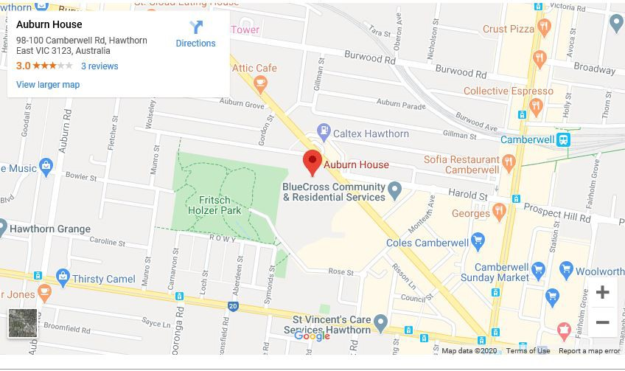
HAWTHORN IS SERVICED BY THREE RAILWAY STATIONS; HAWTHORN, GLENFERRIE AND AUBURN. IT IS ALSO SERVED BY TRAM ROUTES 16, 48, 70, 72, 75 AND 109

