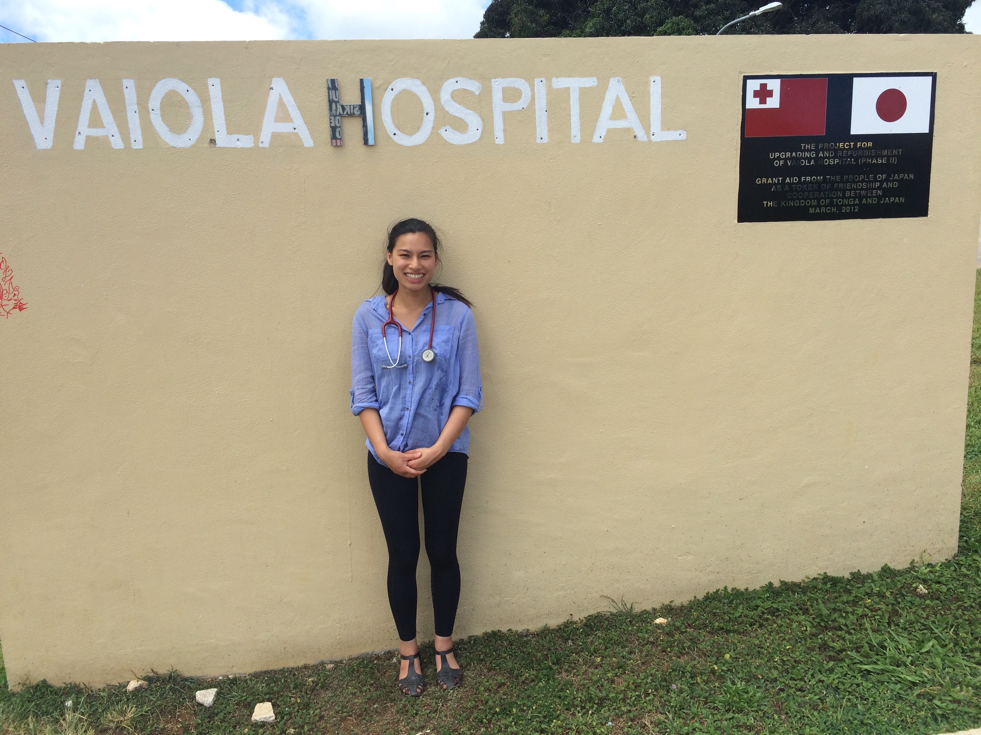
ANDREW DENT SCHOLARSHIP REPORT
Standing outside Vaiola Hospital, Tonga. The Tongan flag shown alongside the Japanese flag displays the close relationship Japan has with Tongan health, offering donations and resources to help improve the health services for Tongan people.
Claire Leong
University of Melbourne (MD3)

In November 2016, I attended a 2-week medical elective at Vaiola Hospital in Tongatapu, Tonga. Although my time in Tonga was short, I was able to immerse myself in daily life at Vaiola Hospital and to share the challenges and triumphs experienced by the medical staff.

The Kingdom of Tonga consists of 171 smaller islands, with Tongatapu being the capital and main island, home to 65% of the population. The population of Tonga is approximately 106,000. This beautiful country is known best for being the “Friendly Island”, and indeed Tongan people prove to be extremely hospitable and generous toward each other and foreigners. Family, religion and food are all important foundations in Tongan culture, and Sundays are kept sacred where all shops and businesses close and allowing Tongans to attend church, spend tie with extended family and of course, feasting.

Tonga’s healthcare system is governed by the Ministry of Health which oversees the operating of the public healthcare services. Implemented in 2015, the Tongan Strategic Development Framework II is a recent movement with aims to improve the delivery of healthcare to Tongans. The mission is to deliver quality health care, improve health promotion and to reduce disability, morbidity and premature mortality. In combination with the World Health Organisation (WHO) and NGOs, the Ministry of Health are striving to be the highest healthcare provider in the Pacific Islands by 2020. Antibiotic resistance is another challenge faced by Tonga and many campaigns have been established to prevent the inappropriate prescription and dispensing of antibiotics (many antibiotics are available over the counter) and to educate health staff and the population about antibiotic resistance. The Tongan antibiotic guidelines are currently being re-written by a group of local and overseas doctors and pharmacists. A large portion of the health services are public, and are free to access for local Tongan people. There are also a small number of privately owned medical practices in the community. There are no General Practices (GPs), thus all medical presentations present to the Outpatient Department or the Emergency Department of the hospital for triage and assessment. Vaiola Hospital is the public hospital on the main island. The hospital consists of six main wards: medicine, surgery, paediatrics, obstetrics and gynaecology, mental health and outpatients/emergency. There are approximately 200 beds in the hospital. Vaiola Hospital also accepts referrals from outer islands, where resources are even more scarce.

During my elective, I spent time in mental health, the emergency department and the surgical ward. During my time on the Mental Health Ward, I was faced with very similar presentations that I have seen in Australia. Some of the differences I learnt were the availability of medications and limited number of laboratory tests available. For example, doctors in Tonga only have first-generation anti-psychotics available (such as haloperidol and chlorpromazine), which are seldom used in developed countries due to their side effect profiles. This leads to poor compliance amongst patients, high re-admission rates and morbidity. Lithium, an effective commonly used mood-stabliser, is also unavailable due to the inability to do blood Lithium levels in Tongan pathology labs. My short experience in the Emergency Department also highlighted the limited pathology and imaging available and encouraged me to remember the importance in taking a thorough history and performing comprehensive physical examinations to formulate differential diagnoses. Throughout my experience in the multiple departments, I was inspired by the doctors’ clinical judgment which relied less on test and heavily on history and examination.
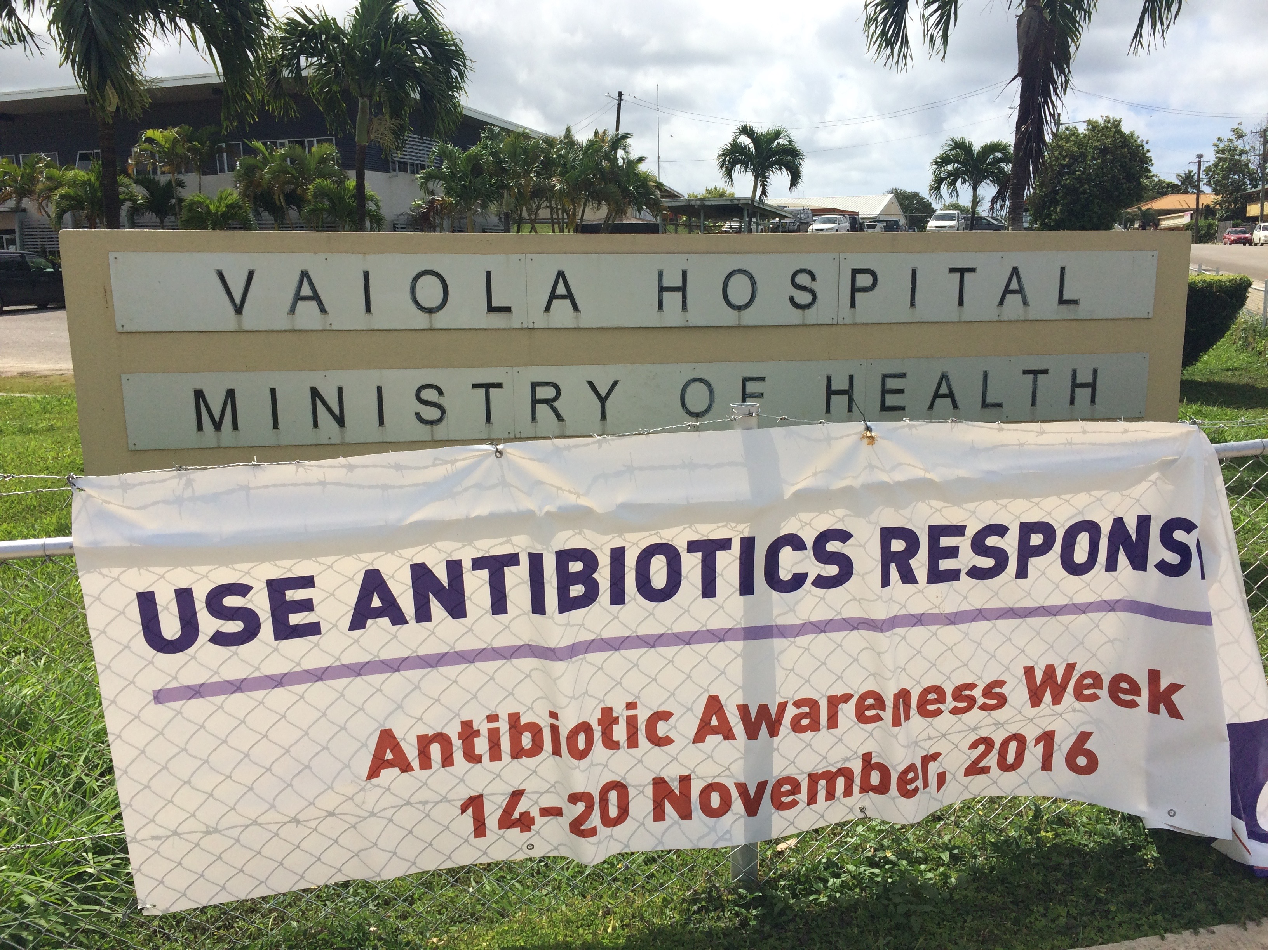
An Antibiotic Resistance Awareness campaign banner outside the Tonga's Ministry of Health building. Antibiotic resistance is an increasingly significant issue in Tonga.
The surgical ward admitted patients who were to have surgery. There were limited surgical specialties available and I spent time with the surgical team who had abundant knowledge on a wide variety of surgical presentations and procedures. A typical day in theatre could include anything from mastectomies, amputations, circumcisions, cholecystectomies, orthopaedic procedures and skin flaps for burns. I was constantly in awe whilst following one surgical team as they jumped from amputating limbs to open abdominal surgery, followed by osteomyelitic wash-out and debridement procedures. In addition to appreciating the tremendous dedication the doctors and other healthcare staff had for their patients, I also experienced first-hand the lack of resources and reliance of foreign donations and help at the hospital. Most ward equipment and supplies (such as cannulas and dressings) were donations of expired equipment from overseas. During my time on the ward, running out of alcohol wipes meant using hand-gel-soaked cotton balls for sterilizing venepuncture and cannula sites. Power outages and oxygen shortages also caused cancelled theatre lists and lengthening waiting lists. Most of the theatre equipment such as endoscopes and ultrasound machines have also been donated by overseas hospitals, yet laparoscopic procedures are still not performed in Tonga due to lack of equipment and training. Specialist surgical teams from visiting countries such as New Zealand, Australia, China and Japan assist on rotating rosters to help educate doctors and perform life-saving surgery on Tongan patients. For example, there is no neurosurgery in Tonga, and patients who require such procedures may be sent to New Zealand or Australia, or may be lucky enough to coincide with an overseas team 1 to 2-yearly visit.

In addition to having limited advanced surgical options, a diagnosis of cancer to Tongans remains a “death sentence” with no cancer treatments besides surgical resection available. There are no chemotherapy or radiotherapy facilities in Tonga, and biologic medications are a rarity. It is upsetting to learn about patients who have potentially curable diseases with modern medicine or whose quality of life would immensely benefit from cancer treatment who are unable to access these resources which are so readily available in Australia. Some patients will be sent overseas for treatment, but this is the minority. A family who were lucky enough to travel to Sydney, Australia for life-saving chemotherapy for cancer shared how the attitude toward cancer is starkly different in Australia. In countries such as Australia, there is so much more hope for cancer patients and this is not observed in Tonga, where patients are given poor prognoses accompanied by poorly controlled symptoms. Stories like this have even further deepened my understanding of the struggles Tonga faces in health and increases my appreciation for the resources and technologies easily taken for granted in Australia.

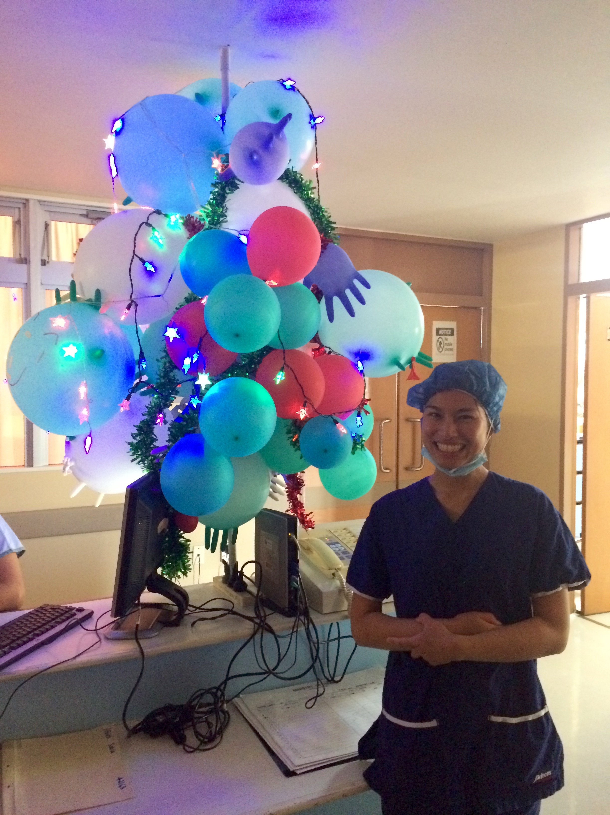
Obesity remains to be another significant medical challenge in Tonga. Tonga is the most obese country worldwide and this sees falling life expectancies, increasing health co-morbidities and poor quality of life. Examples where I saw obesity impacting medical care during my elective included anaesthetic risks and complications, advanced diabetic complications (infected wounds progressing to osteomyelitis, digit and limb amputations and end-stage renal failure in a country without dialysis) and even a gentleman involved in a motor vehicle accident with cervical neck tenderness unable to have a CT scan due to his body habitus. A combination recently introduced Western-style diet, lifestyle and possibly genetics has contributed to over 50% of Tongan men and almost 70% of Tongan women being obese. This puts a large strain on health care resources but in a country where family, religion and food are important pillars in culture, promoting change will prove to be a challenge.
Standing next to a makeshift Christmas tree created by hospital staff on the surgical ward in the weeks leading up to Christmas.

My medical elective at Vaiola Hospital has been an invaluable experience enabling me to engage in Tongan healthcare and understand the challenges faced by the Pacific Islands. I have been motivated by the numerous people I have met on my journey including doctors, nurses, pharmacists, patients and other medical students to continue to aspire to be the best healthcare provider I can possibly be and to offer my services to communities like those in the Pacific Islands to help improve quality of healthcare and health awareness. Many thanks to the generosity of the Andrew Dent Scholarship for helping me fund my eye-opening trip to Tonga which has enriched my interest in global health and has inspired me to return in the near future to broaden my understanding of health and assist in the Pacific Islands.

